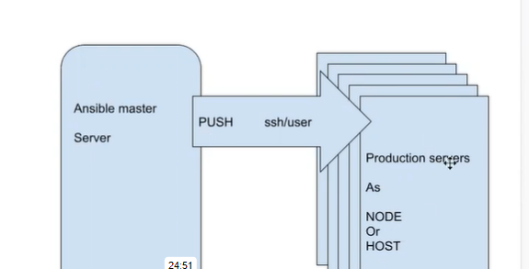

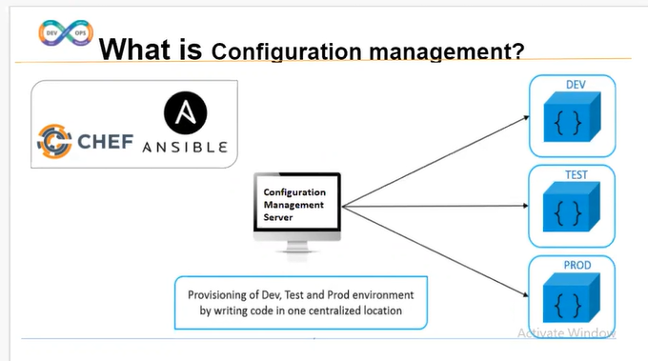

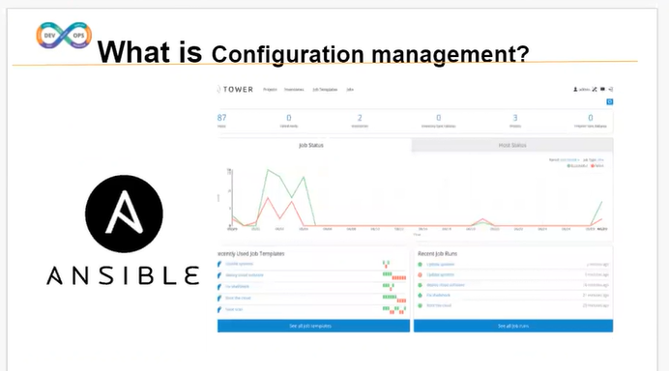

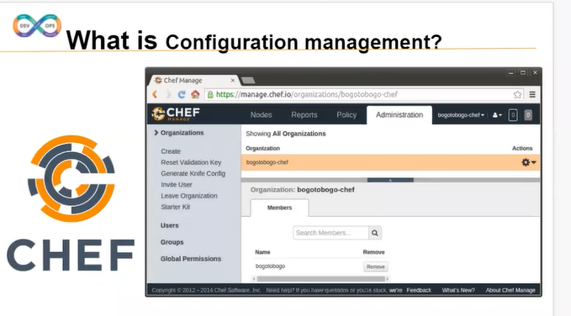

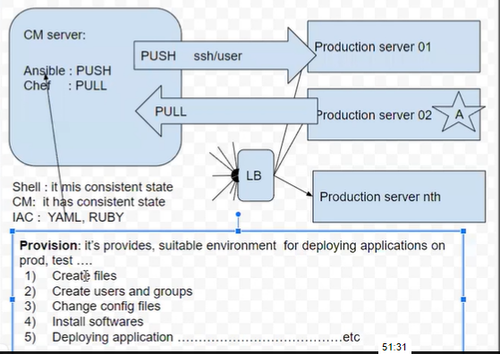

MARCH 10CLASS :

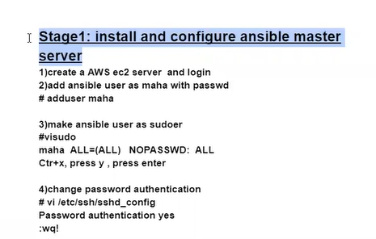

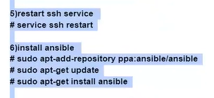

**STAGE 2 :**

**Same as above 5 steps**

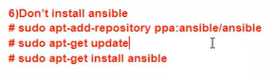

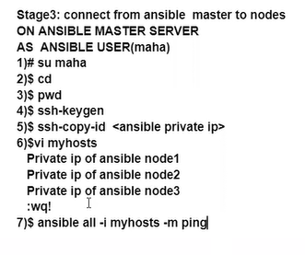

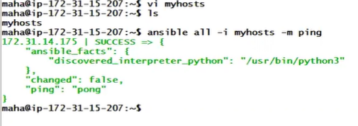

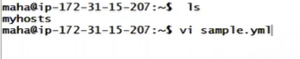

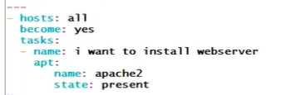

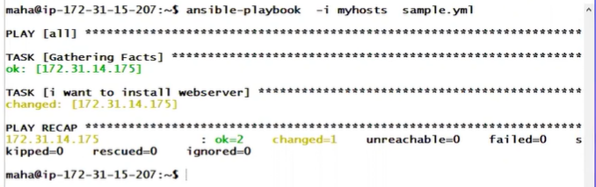

NOTE MARCH 18 CLASS :

**DIRECTLY GIT PUCH IN ADDUSER :**

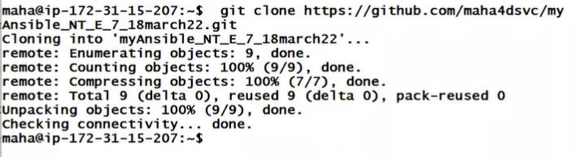

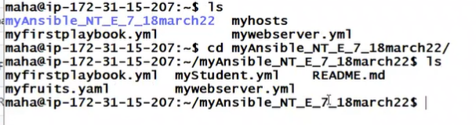

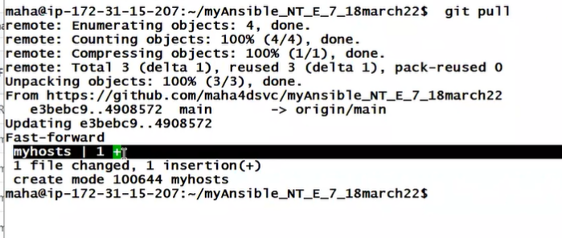

March 11 class :

**WHAT IS ANSIBLE :**

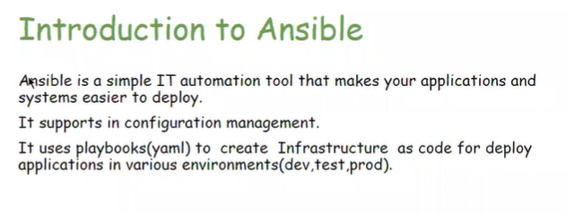

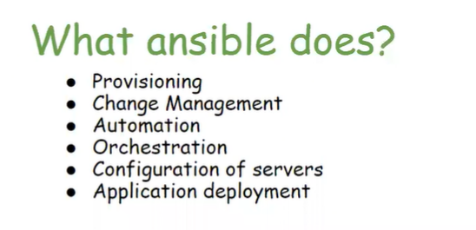

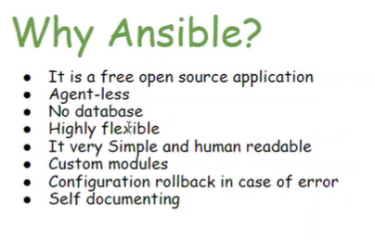

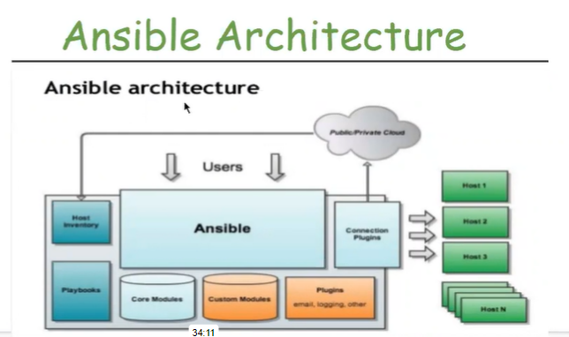

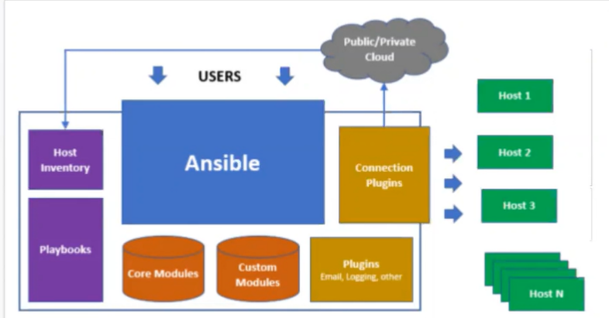

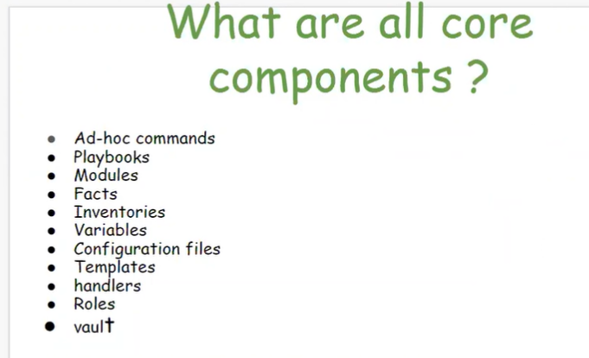

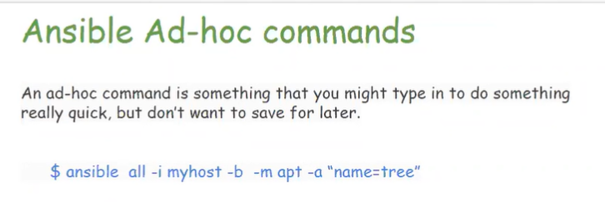

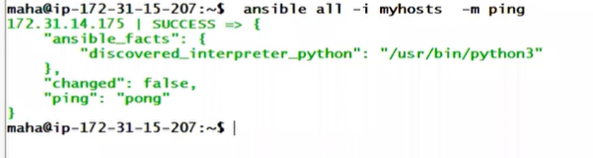

**APPLICATION INSTALL :**



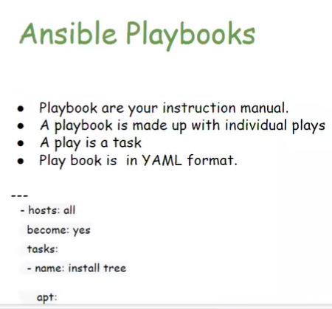

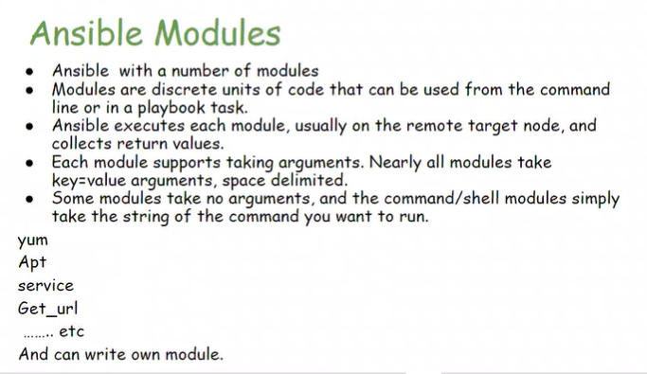

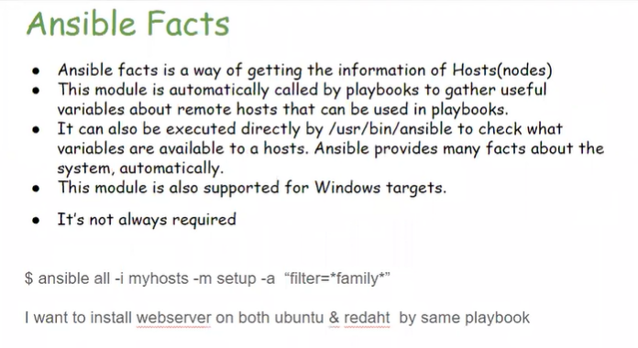

**March 21 class**

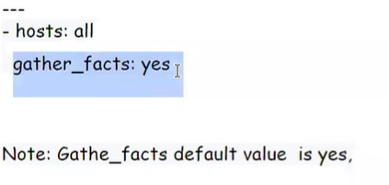

**Ansible details: only one node**



**Searching command:**



**March 22 class :**

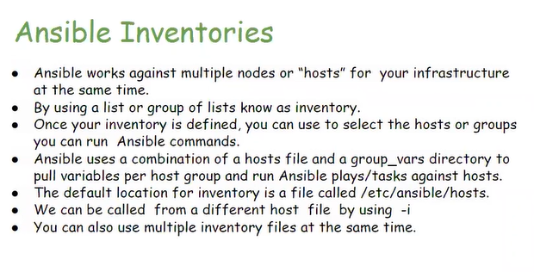



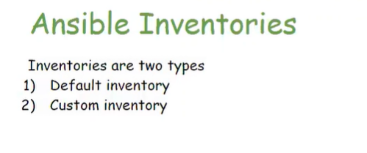

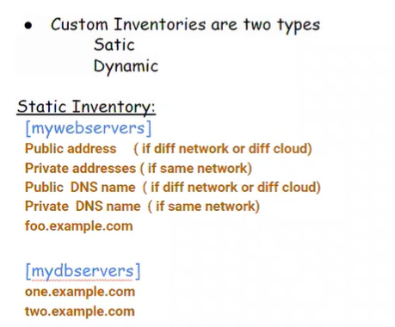

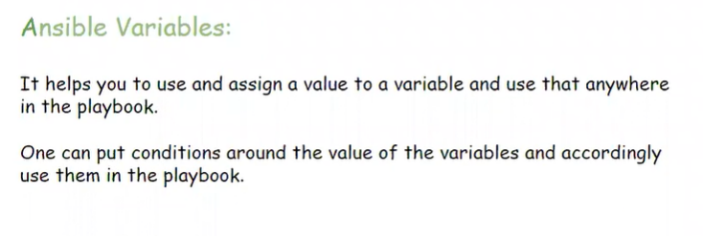

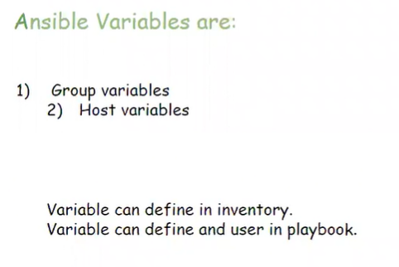

**HOSTS**

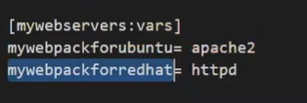

**PLAYBOOK.YAML**

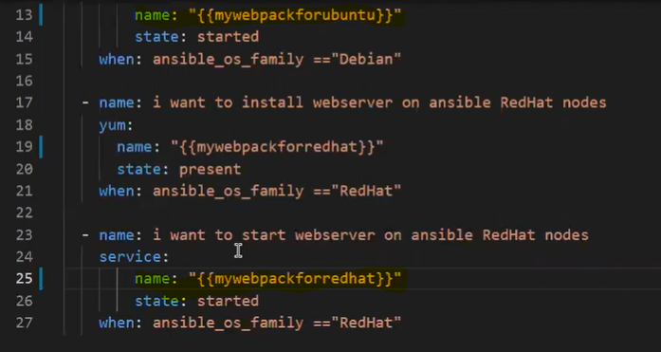

**EXAMPLE CODE :**

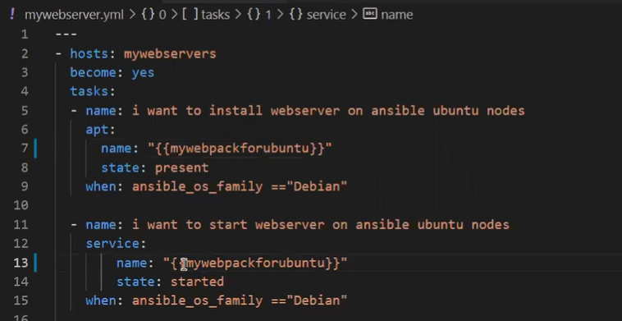

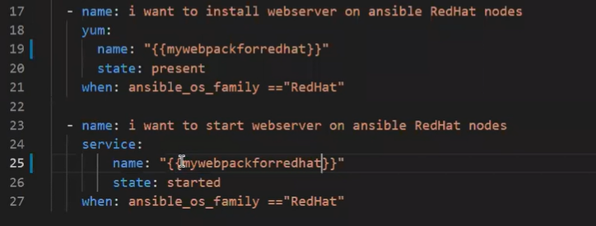

**Files reference**

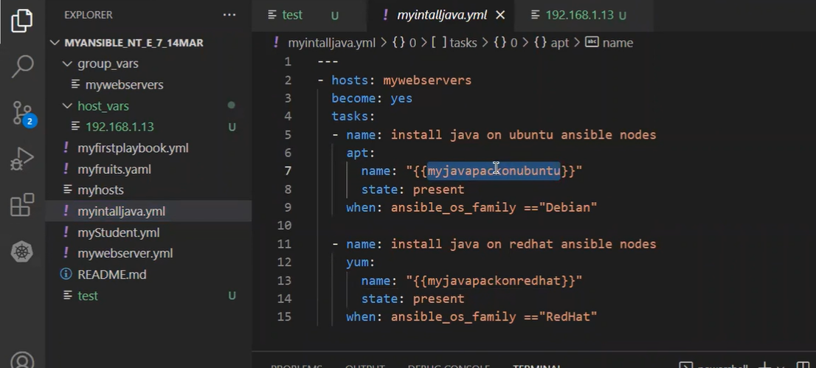

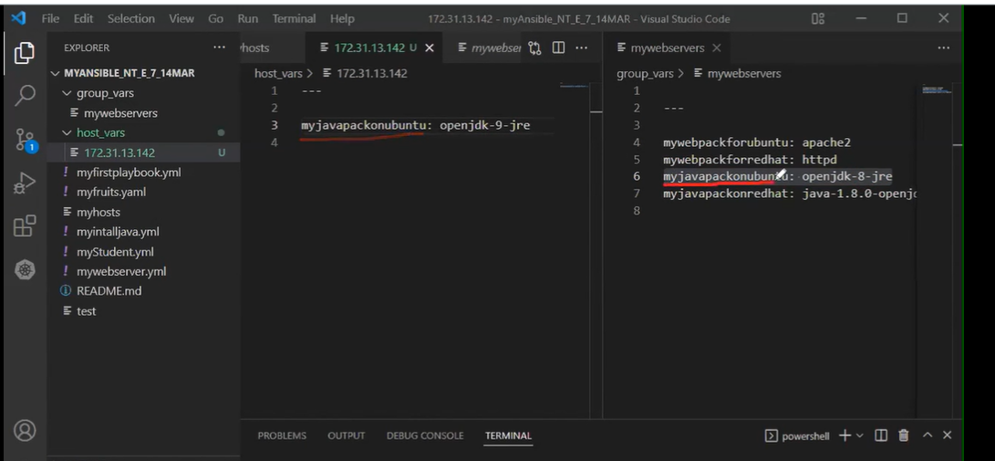

**HOST HAVE A DIFFERENT VALUE EXAMPLE CODE**

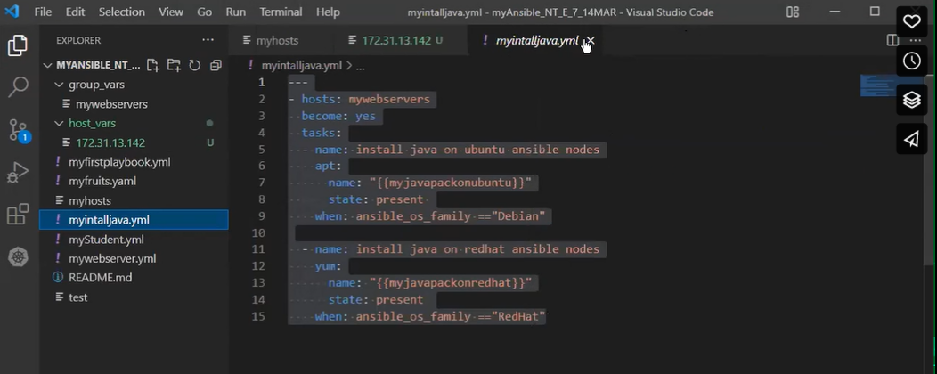

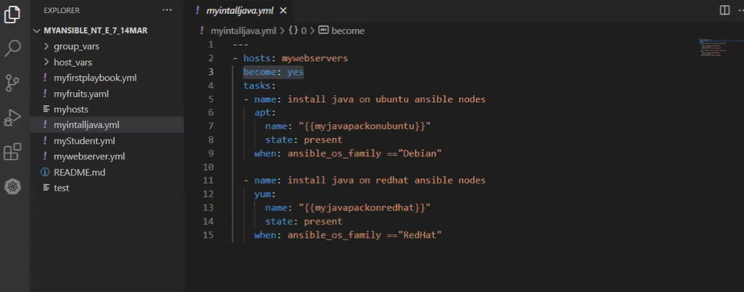

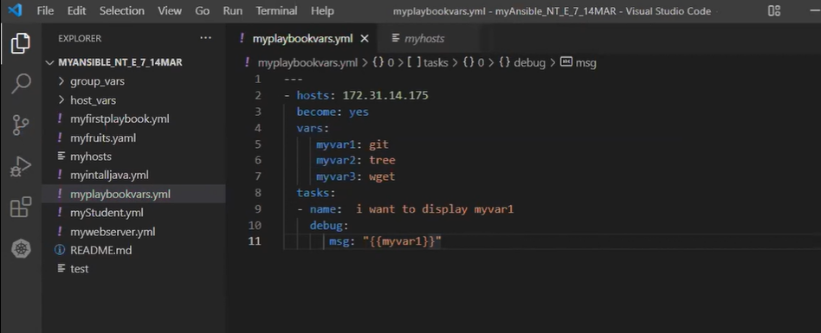

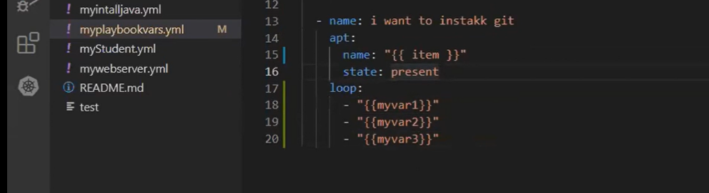

**March 28 class**

**Check hostname :**

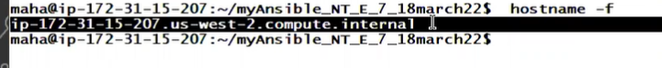

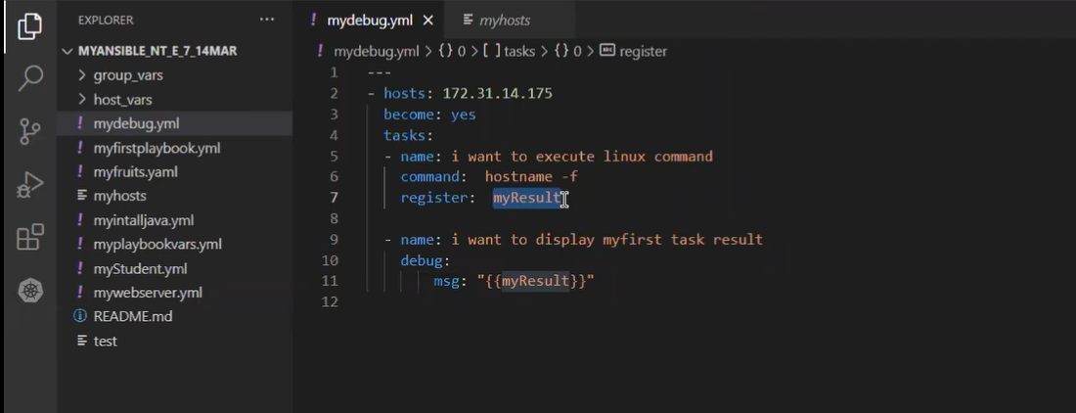

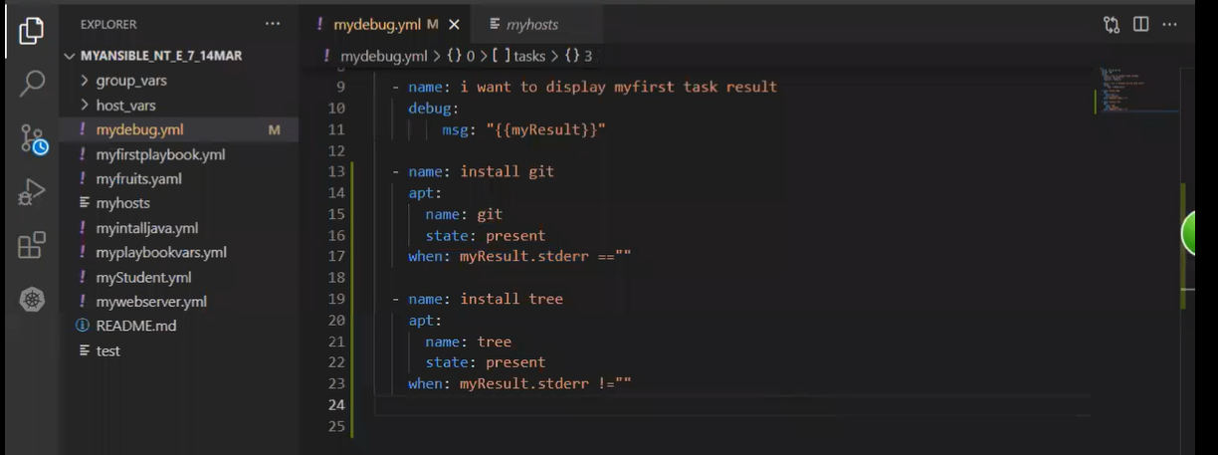

**Tags file :**

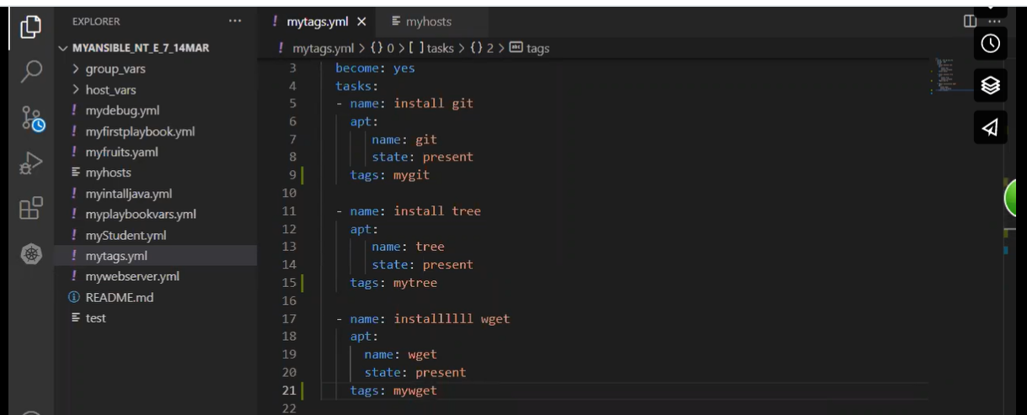

**Tags calling command**



**Error ignore**

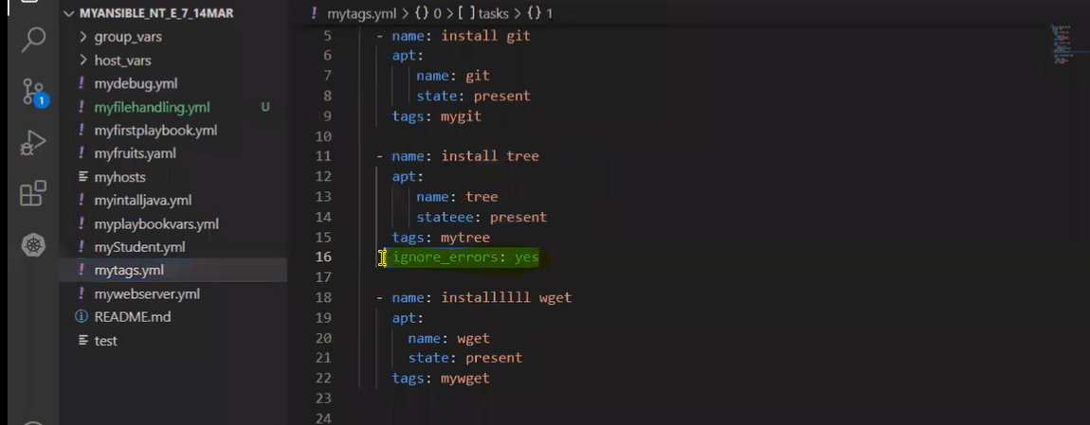

**File creating :**

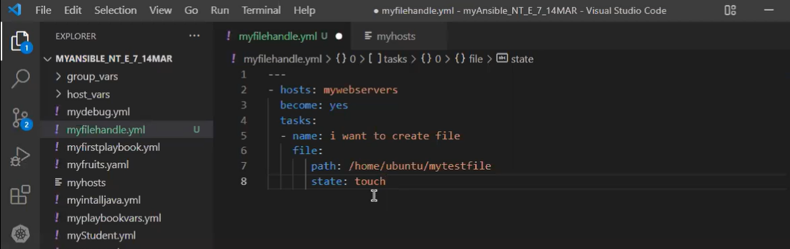

**Step1**

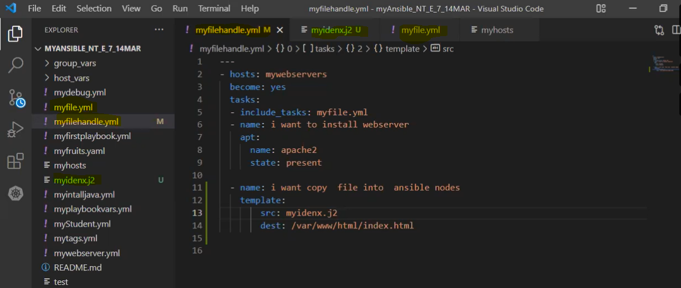

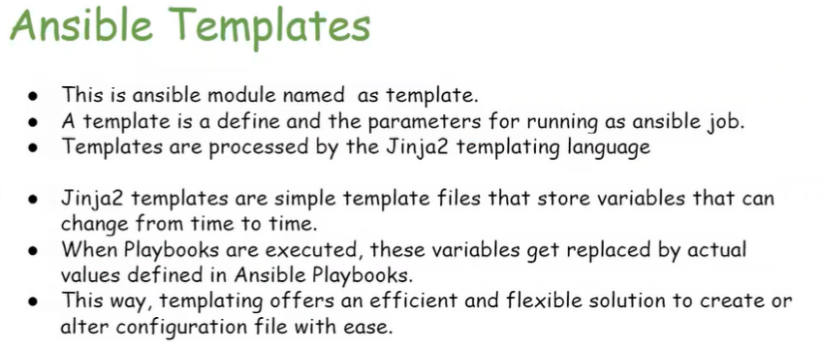

**March 30**

**Restart webserver:(HANDLER)**

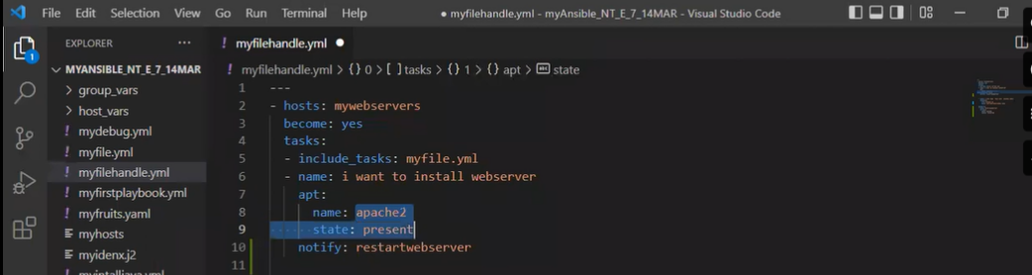

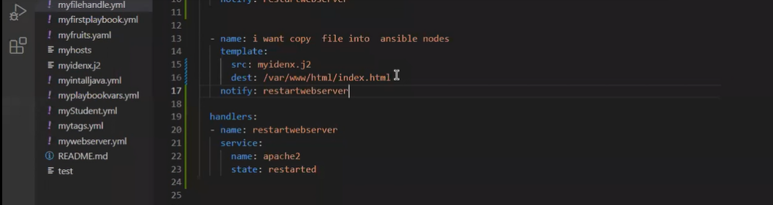

**ROLES**

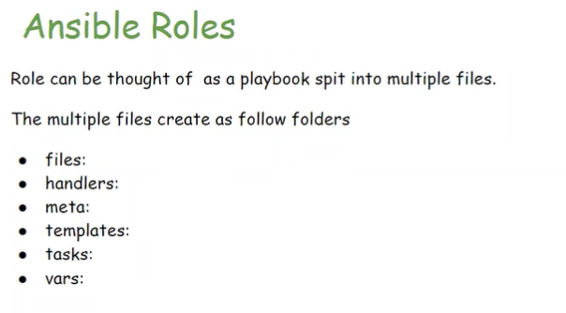

**Folder creating in a ansible**



**$ Sudo apt-get install tree**

**$ tree mywebrole/**

**$ git add -A**

**$ git commit -m “ ”**

**$ git push**

**$ userid: shakeel3132**

**$ passwd : token**

**Roles :**

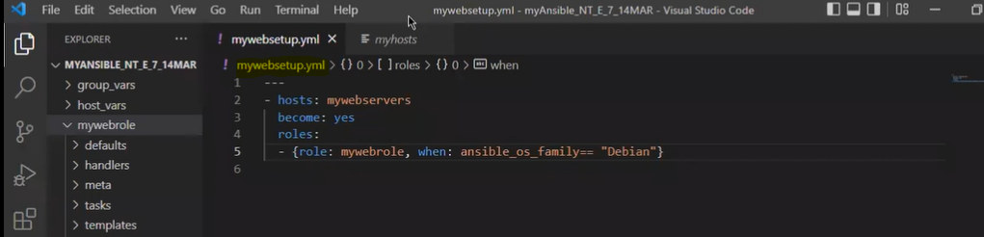

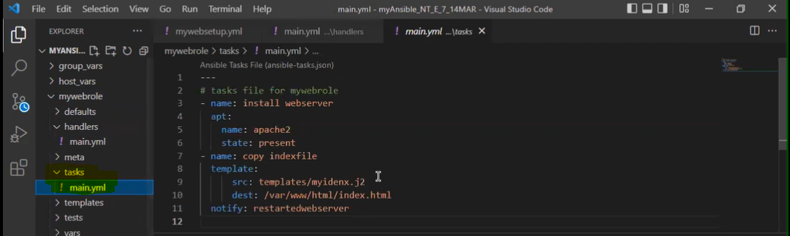

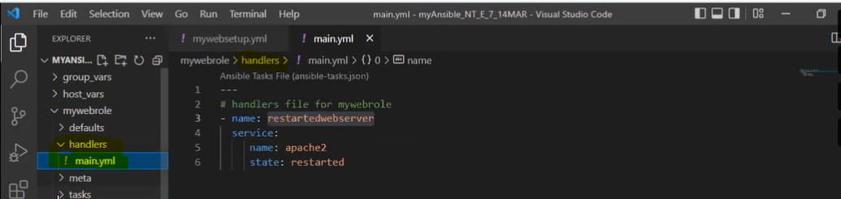

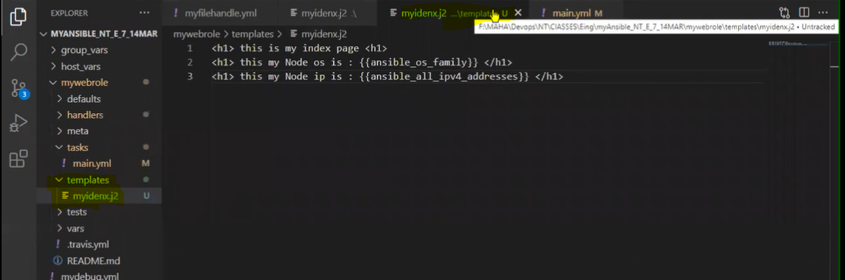

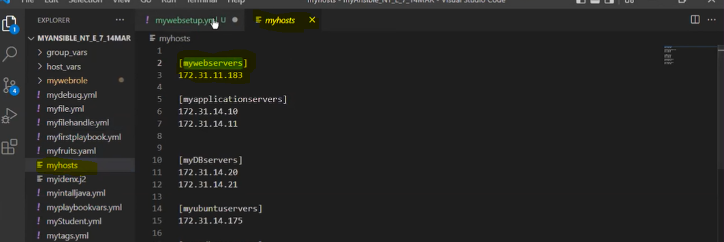

**Tomcat install with help of Ansible**

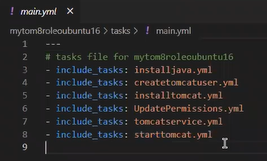

April – 7 class :

**Vaults** :-



Little bit matter in note



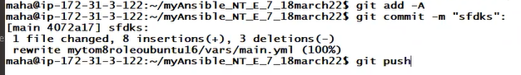

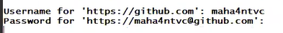

Admin check passwd : use this command



REMOVE PASSWORD : VAULTS DECRYPTION



**April – 8 class**

**Dynamic inventory [Automatic create a EC2 instance ]**

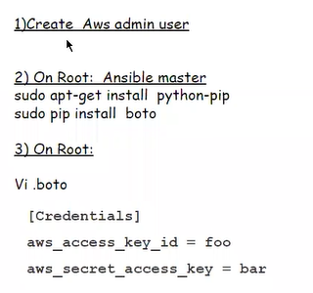

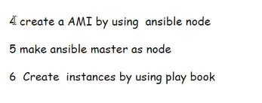

**Playbook**

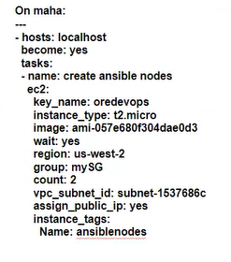

[**https://docs.ansible.com/ansible/2.9/modules/ec2_module.html**](https://docs.ansible.com/ansible/2.9/modules/ec2_module.html)

*# Note: These examples do not set authentication details, see the AWS Guide for details.*

*# Basic provisioning example*

**-** ec2**:**

key_name**:** mykey

instance_type**:** t2.micro

image**:** ami-123456

wait**:** yes

group**:** webserver

count**:** 3

vpc_subnet_id**:** subnet-29e63245

assign_public_ip**:** yes

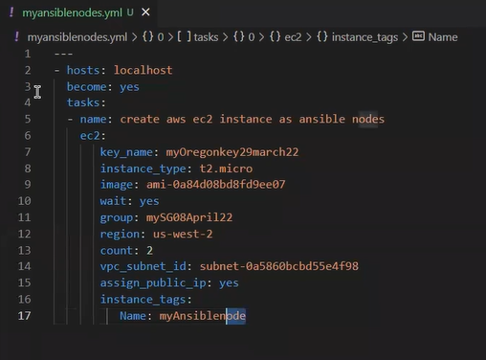

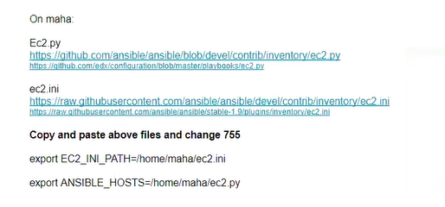

[**https://github.com/vshn/ansible-dynamic-inventory-ec2/blob/master/ec2.py**](https://github.com/vshn/ansible-dynamic-inventory-ec2/blob/master/ec2.py)

[**https://raw.githubusercontent.com/ansible/ansible/stable-1.9/plugins/inventory/ec2.ini**](https://raw.githubusercontent.com/ansible/ansible/stable-1.9/plugins/inventory/ec2.ini)

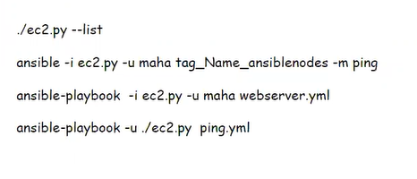



**April – 9 class**